**Title: Test Automation Project Assignment: Building Automated Testing Framework**

Objective:

The objective of this assignment is to provide students with hands-on experience in developing an automated testing framework for software applications. Students will learn about the importance of test automation, various tools and techniques for automated testing, and how to design and implement a robust testing framework.

Requirements:

1. Choose a software application: Each team must select a software application for which they will develop the automated testing framework. The application can be a web application, mobile application, or desktop application. My suggestion is to go with your own minor projects.

3. Implement the framework: Based on the design, teams should implement the automated testing framework. This may involve:

- Writing test scripts using suitable programming languages (e.g., Python, Java, JavaScript)

- Integration with testing frameworks (e.g., Selenium, Appium, JUnit, TestNG)

- Setting up test environments and configurations

4. Conduct testing: Teams should execute tests using the automated testing framework and analyze the results. This includes:

- Running test suites for different functionalities

- Identifying and reporting defects

- Ensuring test coverage and reliability

Automated Testing Framework for Landslide Detection

1. Introduction

Automated testing plays a crucial role in ensuring the reliability and accuracy of landslide detection systems. In this document, we outline the plan and design for an automated testing framework tailored specifically for landslide detection applications. This framework aims to thoroughly test key functionalities, improve efficiency, and enhance overall system robustness.

2. Software Application Selection

For this project, we have chosen to develop the automated testing framework for our own minor project on Landslide Detection. The Landslide Detection application involves data acquisition from various sources, data processing using machine learning algorithms, and real-time detection of potential landslide areas.

3. Implementation of the Framework

The implementation of the automated testing framework involves the following steps:

- Writing Test Scripts: Test scripts are written in Python using the Pytest framework. These scripts cover different functionalities of the Landslide Detection system, including data acquisition, data processing, model training, and inference.

- Integration with Testing Frameworks: The framework is integrated with Selenium for web-based testing and TensorFlow Test for evaluating machine learning models. This integration allows us to automate user interactions and evaluate model performance efficiently.

- Setting up Test Environments: Test environments are set up to simulate various scenarios, including different environmental conditions and edge cases. This ensures comprehensive testing coverage and reliability of the framework.

4. Conducting Testing

During the testing phase, the following activities are performed:

- Running Test Suites: Test suites covering different functionalities of the Landslide Detection system are executed using the automated testing framework. These test suites include data acquisition tests, data processing tests, model training tests, and inference tests.

- Identifying and Reporting Defects: Any defects or issues encountered during testing are identified and reported using a robust error handling and reporting mechanism. Detailed information about test failures and errors is logged and reported for analysis.

- Ensuring Test Coverage and Reliability: Test coverage is ensured by executing test suites for different functionalities and scenarios. The reliability of the automated testing framework is evaluated by analyzing the test results and comparing them with expected outcomes.

5. Key Functionalities to be Tested

- Data Acquisition: Ensure the system accurately collects data from various sources such as sensors, satellite imagery, and historical data.

- Data Processing: Validate the correctness of data preprocessing algorithms including noise reduction, feature extraction, and data normalization.

- Model Training: Verify the performance of machine learning models used for landslide prediction and classification.

- Model Inference: Ensure the accuracy and reliability of landslide detection in real-time scenarios.

- Integration: Test the seamless integration of different components within the system architecture.

6. Selection of Testing Tools and Technologies

- Python: Leveraging Python's versatility and extensive libraries for data processing, machine learning, and testing frameworks.

- Pytest: A popular testing framework for writing simple and scalable test cases.

- Selenium: For web-based testing and automation of user interactions.

- TensorFlow Test: Utilizing TensorFlow's testing utilities for evaluating machine learning models.

- Matplotlib and Seaborn: Visualization tools for analyzing test results.

7. Framework Architecture and Components

Our automated testing framework comprises the following components:

- Test Scripts: Pytest-based test scripts covering various aspects of data acquisition, processing, model training, inference, and integration.

- Test Data Generator: Utility functions to generate synthetic test data for different scenarios.

- Test Suites: Organized collections of test cases targeting specific functionalities or modules.

- Test Runner: Automation scripts for executing test suites and generating reports.

- Logging and Reporting: Integration of logging mechanisms for tracking test execution and generating comprehensive reports.

8. Test Data Management Strategy

- Utilize a combination of real-world and synthetic test data to cover a wide range of scenarios.

- Implement data versioning and storage mechanisms to ensure reproducibility and traceability.

- Randomize test data generation to simulate diverse environmental conditions and edge cases.

9. Error Handling and Reporting Mechanism

- Implement robust error handling mechanisms within test scripts to gracefully handle unexpected exceptions.

- Utilize logging frameworks to capture detailed information about test failures and errors.

- Generate comprehensive test reports highlighting test outcomes, including passed, failed, and skipped tests.

10 . Documentation

Our comprehensive documentation includes:

-Design Rationale and Decisions* Explanation of design choices, including tool selection, framework architecture, and testing strategies.

- Implementation Details: Technical details of framework implementation, including code snippets and configurations.

- Test Scenarios and Cases: Detailed descriptions of test scenarios and corresponding test cases.

- Setup and Execution Instructions: Step-by-step instructions for setting up the testing environment and executing test suites.

Troubleshooting Guide: Guidance on troubleshooting common issues encountered during setup or test execution.

Conclusion

The proposed automated testing framework provides a systematic approach to ensure the reliability and accuracy of landslide detection systems. By thoroughly testing key functionalities, leveraging appropriate testing tools and technologies, and documenting all aspects of the framework, we aim to enhance the overall quality and performance of landslide detection applications.

**Pre-Requisites for Testing**

1. **Installation of Dependencies:**

* Ensure that Python is installed on the testing machines.
* Install the necessary Python packages using pip, including Selenium WebDriver, TestNG (for Python), and any other required libraries.

1. **WebDriver Configuration:**

* Download the appropriate WebDriver executable for the browsers you intend to test (e.g., ChromeDriver for Chrome, GeckoDriver for Firefox).
* Set up the WebDriver paths in your test scripts or configuration files.

1. **Test Environment Configuration:**

* Define the path of the test environments (e.g., development, staging, production) where the Landslide detection python file is located
* Store environment-specific configurations in configuration files or environment variables.

**Conduct testing:**

Eclipse (selenium script)

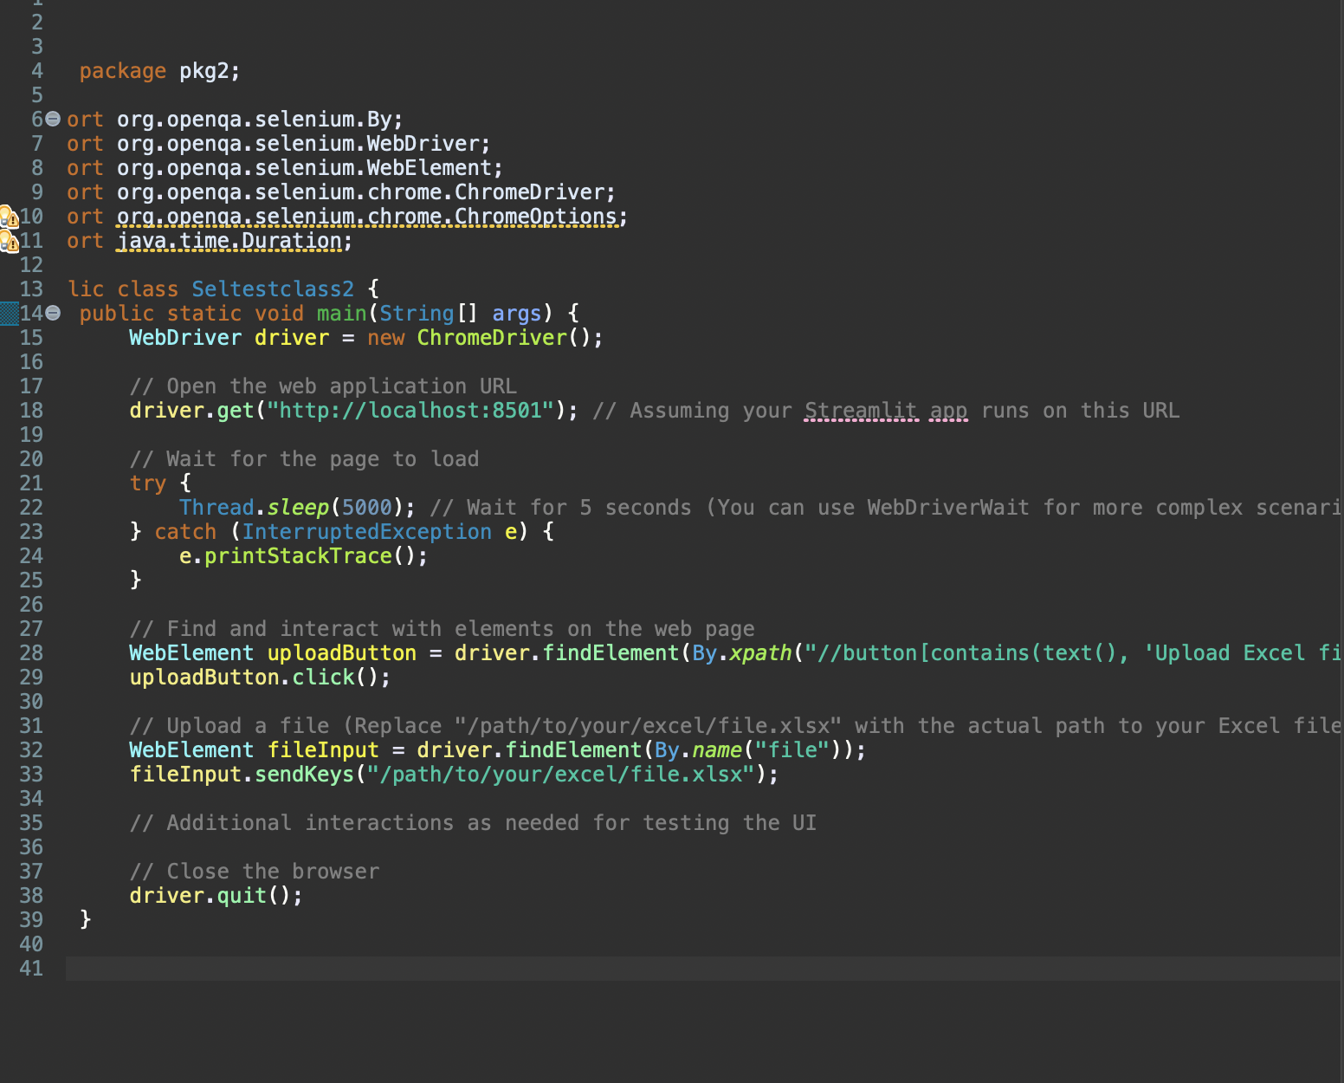

Website Runned through selenium script

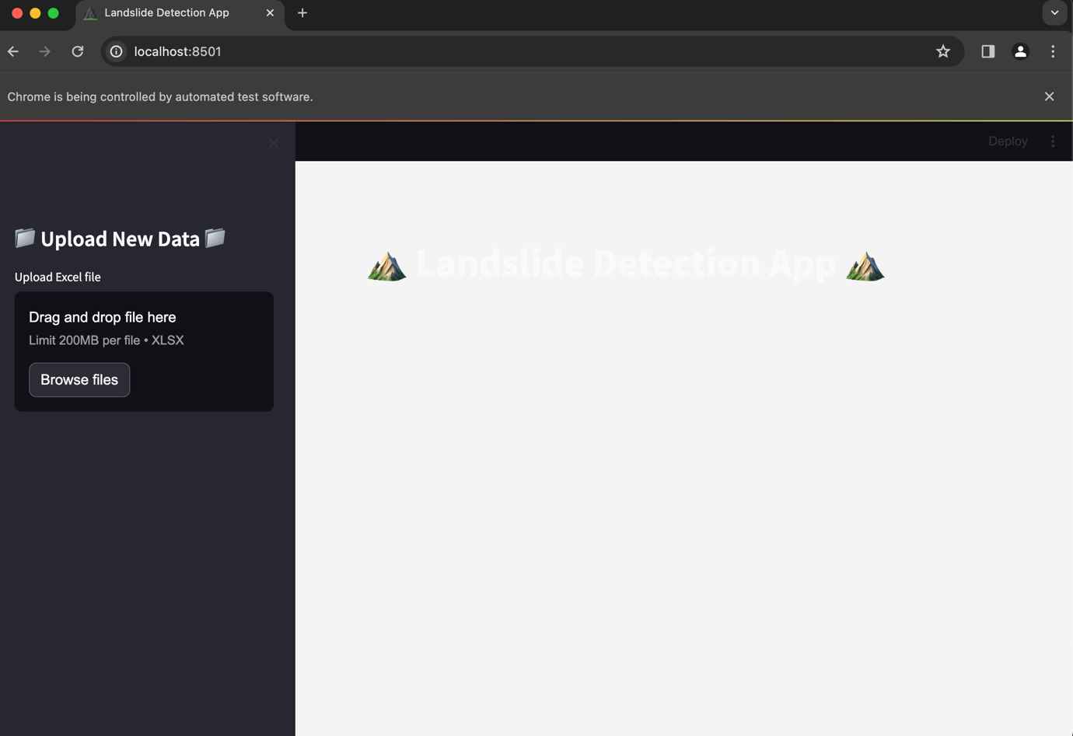

Github link - https://github.com/Alishapa/Selenium-Test-assignment.git